1. In the previous lecture, we created Elastic BeanStalk App in a particular region (US East (N. Virginia)).
2. What is region and why do we need them?
3. 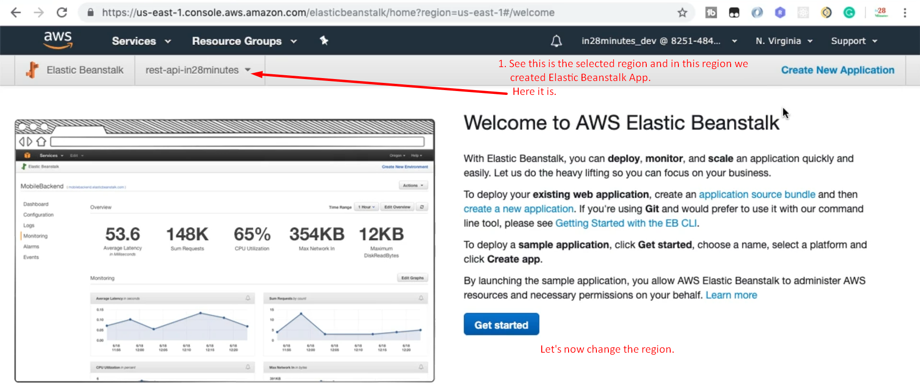
4. 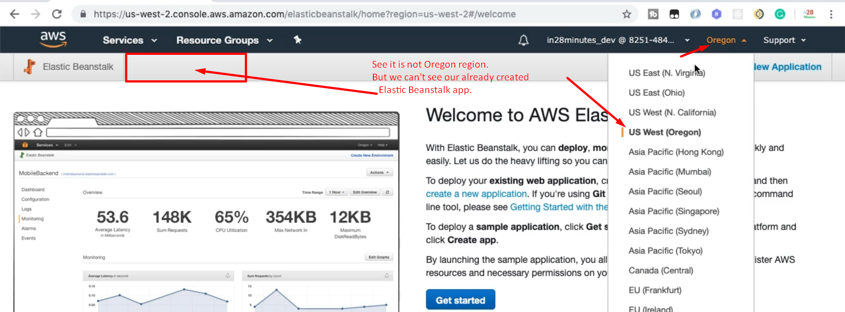
5. Now let’s see why regions?
6. 
7. Why regions;
   1. **Performance**: If you have users from India and the host is in California, the request would take much time to serve. So better to have host in Mumbai.
   2. **Availability**: Deploy your app across multiple regions to avoid a particular national calamity.
8. At the time of this lecture, Amazon has 21 regions and they are planning for more.